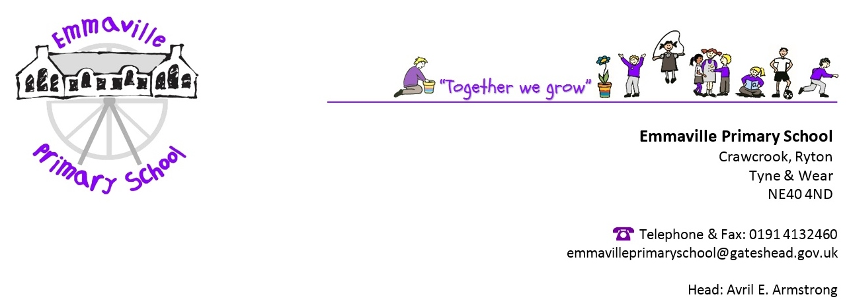
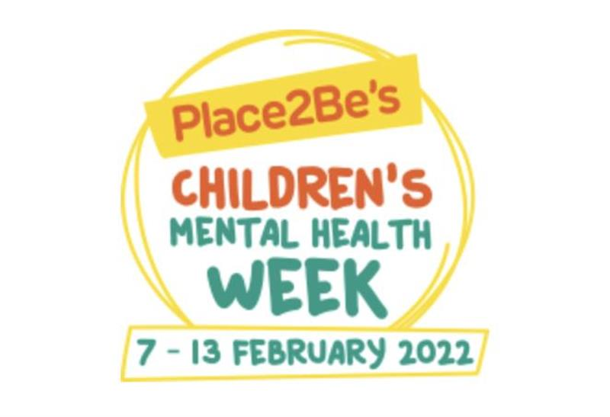
Dear parents/carers,

It is Children’s Mental Health week from 7 – 13th February, and as a school, we will be engaging with and supporting this week as we feel the wellbeing of our pupils is of paramount importance.
Children’s Mental Health Week is an opportunity to shine a spotlight on the importance of children and young people’s mental health. By getting involved, we will not only be raising important awareness, but also vital funds to help more children and young people get the emotional support they need.

As our lives continue to adjust following the impact of coronavirus, we know that children and young people need our emotional support now more than ever. In fact, research shows that up to 1.5 million children and young people across the UK need mental health support as a direct consequence of the pandemic.

Within school, we will be having a “wellbeing day” on Friday 11th February and will also be inviting the children to come to school in non-uniform; the theme of the non-uniform is “dress to express”. Children can come to school in clothes they feel express themselves in some way. This can be simply their favourite outfit, favourite colour or representing a hobby they enjoy. They can be as creative as they want!

Please can children bring a small donation to school on Friday 11th to support this worthwhile charity. The suggested donation is £2, but every little helps.

Many thanks for your support
Emmaville staff

