Wednesday 14th October
Content objective:
To investigate whether different materials have different properties
Me
Teacher
Skill objective:
To use a range of equipment carefully and correctly
Me
Teacher
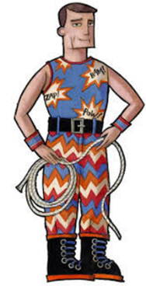
Traction Man loves to wear different outfits when he is completing his different missions. However, he has found that when he is exploring in the forest, his suits keep getting holes in.
We need to investigate different fabrics to see which is most durable and therefore best for Traction Man’s forest exploration outfit.

Prediction

Results
Fabric | Number of rubs with sandpaper before a hole appeared
Denim
Sweatshirt
Cotton vest
Felt
Lycra

