Matilda lived in Dull-on-Sea, a gloomy seaside town –
too busy in the summer…and in winter it shut down.
There weren’t too many kids around – just Tilda on her street.
The lawns were mowed, the cars were washed, the hedges trimmed and neat.
The house next door had been for sale since Tilda was a baby.
She hoped a family would move in with a girl of her age or maybe…
A boy! A PIRATE BOY! AHOY!

He had patched-up jeans, an EYEPATCH and a WOODEN-LEGGED dog!
And a PIRATE SHIP with TREASURE CHESTS and barrels full of GROG!
“We’re the JOLLEY-ROGERS! We’ll be anchoring next door,
We’ve sailed the seven seas but now we’ve had to come ashore.”
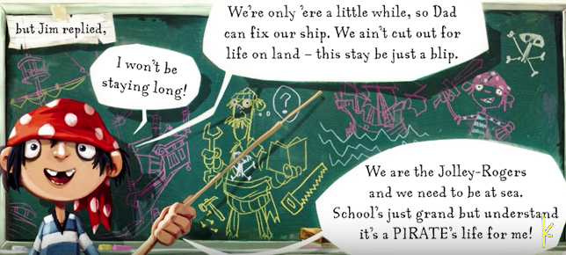

Next morning, Tilda blurted, “Life’s not BORING anymore!
Isn’t it FANTASTIC that those pirates moved next door?”
But Mum and Dad were not impressed, “The neighbourhood will sneer.
The way they dress – the way they speak!
They won’t fit in round here.
Their lad is always playing with the most alarming toys…
We’d rather you were friends with NORMAL girls and boys.”

But that very day young JIM LAD came to Matilda’s school.
Though NO ONE else would sit by him…Matilda said, “You’re COOL!”
“You ain’t so bad yourself, my lass. For a landlubber, that’s rare.
I’m a SCURVY SEA DOG, but ye’ll be alright sitting there!”

The teacher said Jim should wear SHOES and his uniform was wrong.
She wrote a note, but Jim replied, “I won’t be staying long!
We’re only ‘ere a little while, so Dad can fix our ship.
We ain’t cut out for life on land – this stay be just a blip.
We are the Jolley -Rogers and we need to be at sea.
School’s just grand but understand it’s a PIRATE’S life for me!”

