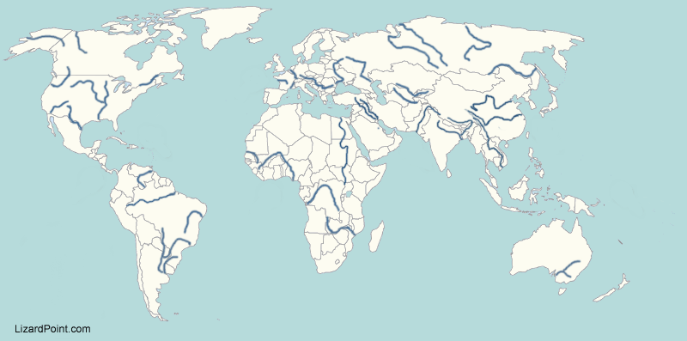
LO: To locate rivers of the world using an atlas
River | Source (Country/state/area) | Mouth | Countries on its course | Length (km)
Amazon
Congo
Ganges
Mississippi
Nile
Ob
Yangtze
Loire
Indus

