WC Monday 8th March
LO: To use compass directions
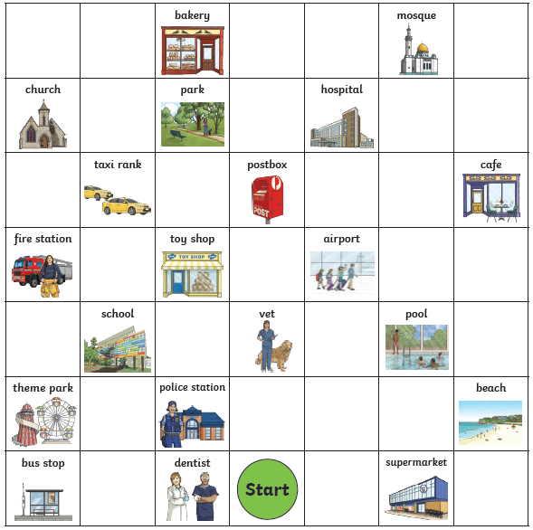

From the start, go North 4 squares. Where are you now?
Go east 3 squares. Where are you now?
Go south 3 squares. Where are you now?
Go west 6 squares. Where are you now?
Go east 2 squares. Where are you now?
Start at the school. How do you get to the taxi rank?
Give directions from the dentist to the toy shop.

