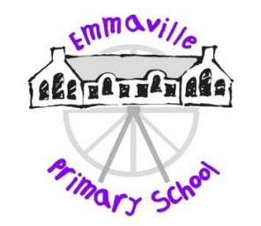

British Values at Emmaville Primary School

The Department of Education has recently reinforced the need “to create and enforce a clear and rigorous expectation on all schools to promote the fundamental British values of democracy, the rule of law, individual liberty and mutual respect and tolerance of those with different faiths and beliefs."

At Emmaville Primary School these values and attitudes are promoted by all staff, who provide a model of behaviour for our pupils. The principles will be taught to the children in a variety of ways, as detailed below and the children will encounter these principles in everyday school life. We have a strong commitment to developing the Spiritual, Moral, Social and Cultural attitudes of the children at Emmaville, we want the children to be excellent citizens and this is developed through all aspects of the curriculum.

**Democracy**

* Children involved in democratic processes such as choices for class jobs, class reading books, non-uniform/charity events and school council elections
* Class charters
* Pupil voice/questionnaires

**Tolerance of those of different faiths and beliefs**

* RE/PSHE teaching
* Assemblies and Inter-Faith Day/Week
* Visitors are invited into school to share their knowledge from different faiths and beliefs
* Visits to places of worship of world faiths
* Promoting languages of EAL pupils
* Assemblies to celebrate festivals such as Hanukah, Diwali, Eid-al Fitr Christmas and Harvest

**Individual Liberty**

* PSHE teaching
* Pupils have roles in schools e.g. buddies and helpers
* Pupils are encouraged to make choices in a safe and secure environment
* School values and ethos is shared by all members of the school community
* Extra-curricular activities
* Emmaville’s Got Talent

**Respect**

* PSHE/RE teaching
* Children are recognised and praised for showing respect
* Class discussions teach children to take turns and listen to each other’s opinions
* School rules/choices policy
* Children take part in celebration assembly
* Children support local and national charities

**Rule of Law**

* Class Charters where children formulate their own rules for their class
* Playground and safety rules
* Pupils have regular opportunities to reflect on behaviour, learning and across the curriculum
* School links with community police services
* Visits from local councillors
* Rewards systems to encourage positive behaviour