Science: Animals including humans.
We are starting a new science unit. We will be looking at animals, including humans.

As part of this work we will be learning to identify that animals, including humans, need the right types and amount of nutrition, and that they cannot make their own food (like plants do) so they get nutrition from what they eat.
We will also be learning about skeletons and muscles and how they can be used for support, strength, protection and movement.

Key Terminology:
Nutrition, nutrients, diet (balanced/unbalanced), sugar, protein, fat, vitamins, minerals, water, energy, oxygen, feeding, eating, photosynthesis, circulation, blood, heart, vertebrate, invertebrate, skeleton (simple examples of bones), support, protection, movement
Science Model:
Energy transfer models (like the arrows we used to show force)
Cycles – eg life cycles

You have 3 tasks to complete this week
Task 1.
Find the meaning of the words

Herbivores -

Omnivores -

Carnivores -

Create a large Venn diagram with the labels, Herbivores / Omnivores / Carnivores.
Sort out the animals into a Venn diagram using the clues under each picture to help you.

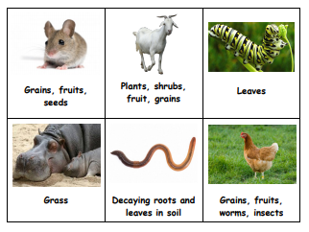
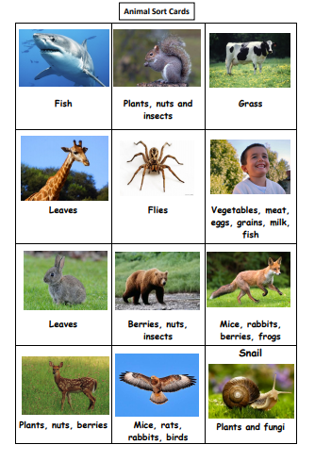
-

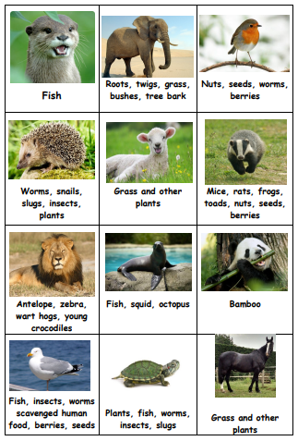

Task 2.
Watch video of feeding time at the zoo https://www.bbc.co.uk/bitesize/clips/z3txpv4 write a short explanation as to why animals need a healthy diet.

That goes for us as well –

Task 3.
Answer these questions using your own ideas and understanding about humans and the food we eat. We will be looking at more information about this in next week’s work, this is just to see what your ideas are.

What do you like to eat?

What do we need to eat?

Is there a difference between those answers?

If yes, why do you think that is?

Why do we need to eat food?

How does food give us energy? (think about food being fuel)

