01.12.21

L.O: To count in pence.

1. Match the coin to its value.

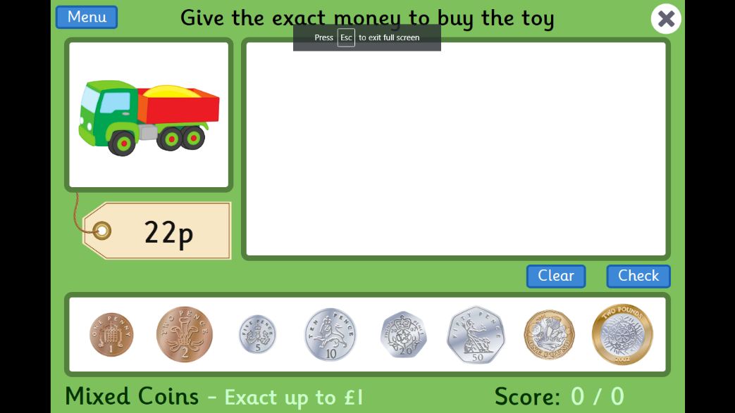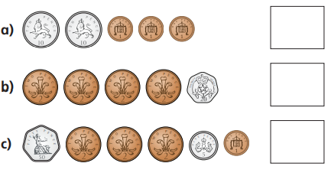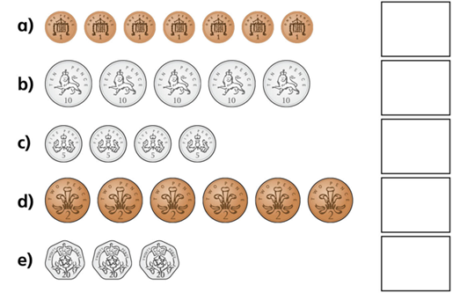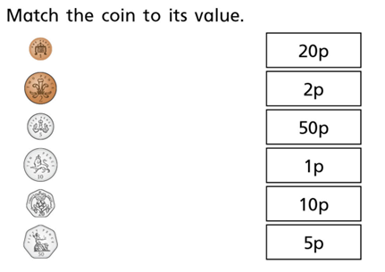

Challenge- Now play Topmarks Toystore game on the Ipad. Can you give the exact amount of money to buy the toys?

1. How much money is there?
2. How much money is there?