Art – Make Medals

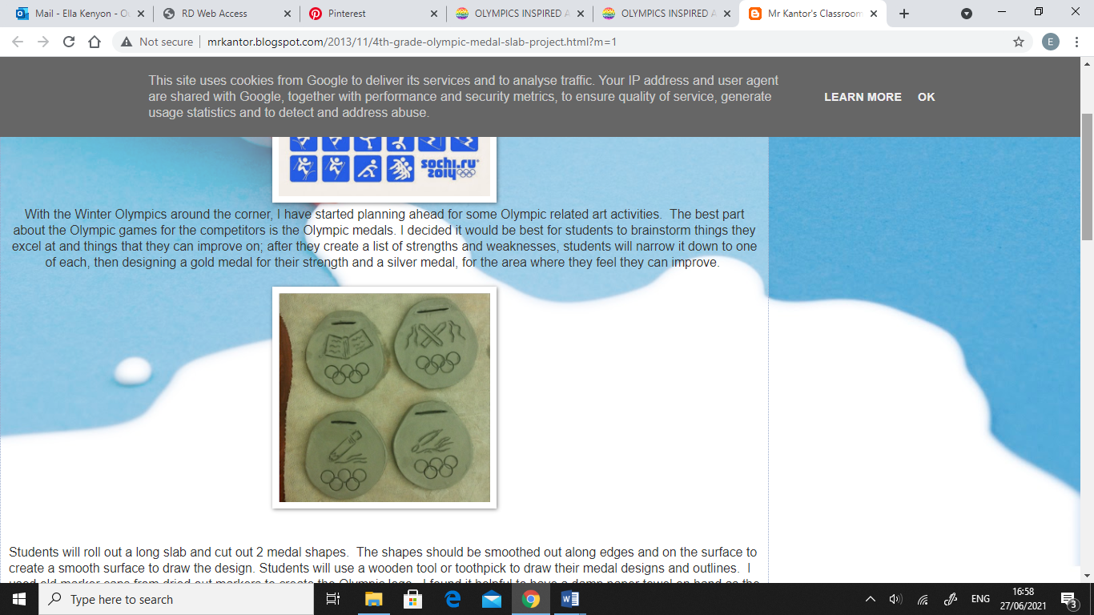

Think about what you excel at and things that you can improve on. Create a list of strengths and weaknesses, and then narrow it down to one of each.

Design a gold medal for your strength and a silver medal, for the area where you feel you can improve.

Create your medals with anything you have at home e.g. plasticine, cardboard, paper, foil etc.

