The Tomb of the Emerald Snake
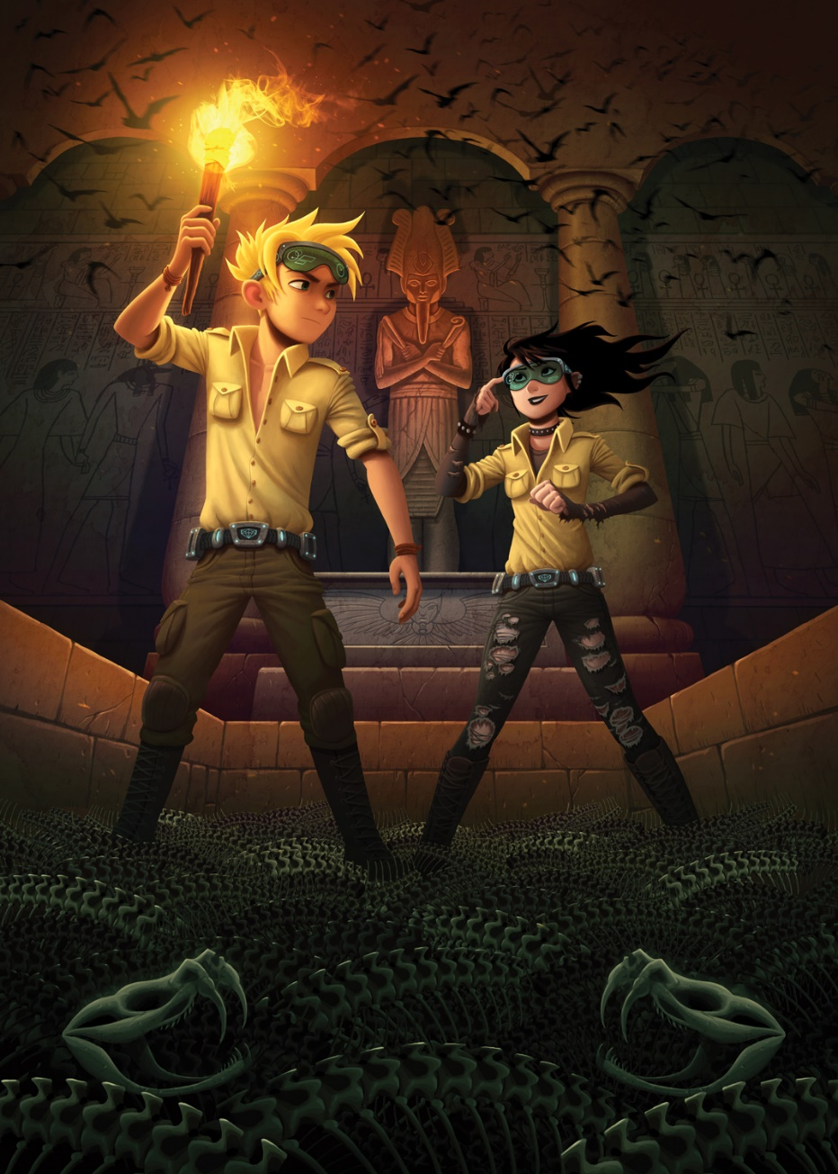

Possible ideas
- What is the place? Describe the setting and include key words: bat, tomb, hieroglyphics, columns, sarcophagus, shadow, torch, flame.
- Who are the people?
- Why are they there?
- Why are they wearing special glasses and belts? What do they?
- Who was buried inside the tomb?
- Why is it called the tomb of the emerald snake?
- Write a time travel story linked to this picture.

