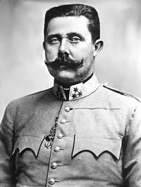

Murder of Archduke could lead to war!

28th June 1914