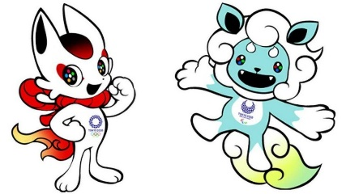
WC Monday 5th July
L.O. To design an Olympic mascot.

Now tell me about your Olympic mascot…

