Using your atlas, add labels to the Great Lakes of North America.
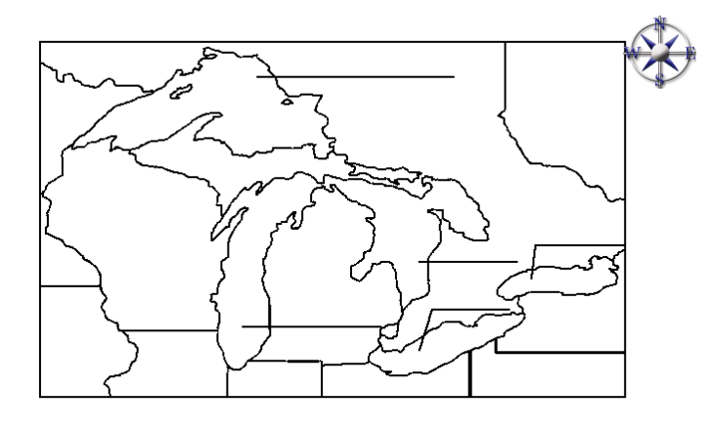
Using your atlas, add labels to the Great Lakes of North America.

