Make a Kite
The task is to make and decorate your own kite. You could even use recycled materials to make yours. Here is one below made from an envelope and drinking straws, but you might have your own ideas.
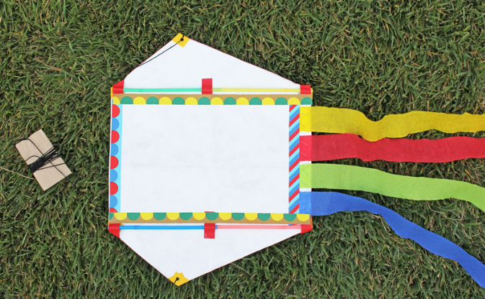
We thought making kites would be great as it is a symbol of Japanese tradition, as the Olympics will be held in Tokyo. It also encourages you to get outdoors and keep active.

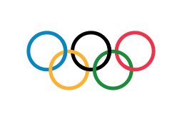
Finally, Miss Armstrong wants you all to aim high and know that you are all our ‘superstars’ with the challenging year that you have had. We are incredibly proud of you all!

You could decorate your kite with Olympic values, Olympic symbols or even just make it brightly coloured.

Follow the link to find out more about kite flying in Japan. Then make and decorate your own kite.
https://www.kcpinternational.com/2012/03/kite-flying-in-japan/

