Tuesday 13th October
LO: To punctuate sentences correctly; to use expanded noun phrases
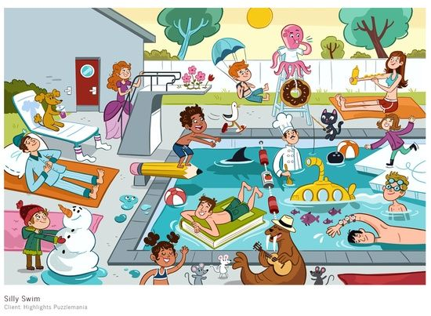

Tuesday 13th October
LO: To punctuate sentences correctly; to use expanded noun phrases

