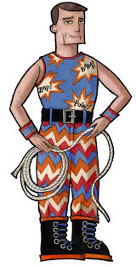
Monday 5th October
LO: To generate a toolkit for characterisation
Fraction Man
Fraction Man is here, wearing his subtraction boots, addition vest and fraction cape. He is preparing for another day of adventures!
At breakfast time, Fraction Man is in the kitchen. Unfortunately, the toaster has turned into a deadly dragon and is breathing fire all over the dish cloth. Luckily, Fraction Man swoops down on his supersonic teapot and pours tea all over the flames. “Hooray, you’ve saved me,” cries the dishcloth.
At lunch time, Fraction Man is in the classroom. Unfortunately, evil Doctor Dictionary has stolen all of the pencils and has trapped them in the bin. Luckily, Fraction Man finds a ball of string, he climbs down into the bin and hauls out all of the pencils. “Well done Fraction Man, we were getting worried until you came along!” cheer the pencils.
In the afternoon, Fraction Man is in the sitting room. Unfortunately, the villainous Scissor Shark is about to cut up all of the paper dollies. Fortunately, Fraction Man grabs a tissue and throws it over the Scissor Shark and leads the dollies to safety. “Why thank you Fraction Man,” chime the paper dollies.
This is the end of the amazing adventures of Fraction Man, for today at least!

Choose good names
Powerful adjectives
Well-chosen speech
Powerful verbs
Clear beginning, middle and end

