14.6.21

LO – I can subtract amounts of money.
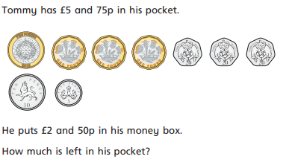
1.

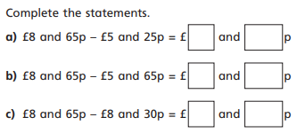
2.

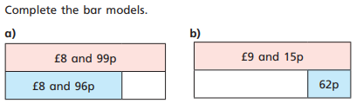
3.

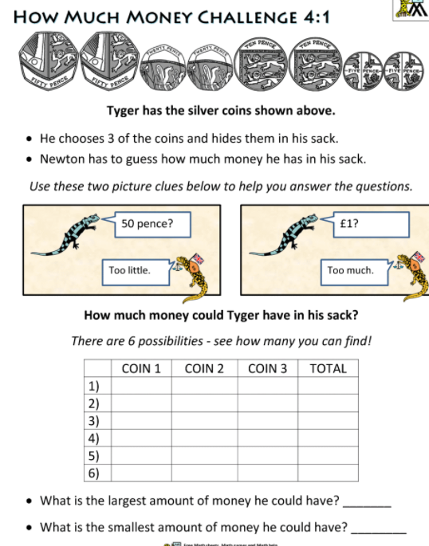
4. This is today’s challenge.
(There are some copies to stick in your
book if you get this far)!

