Week 3

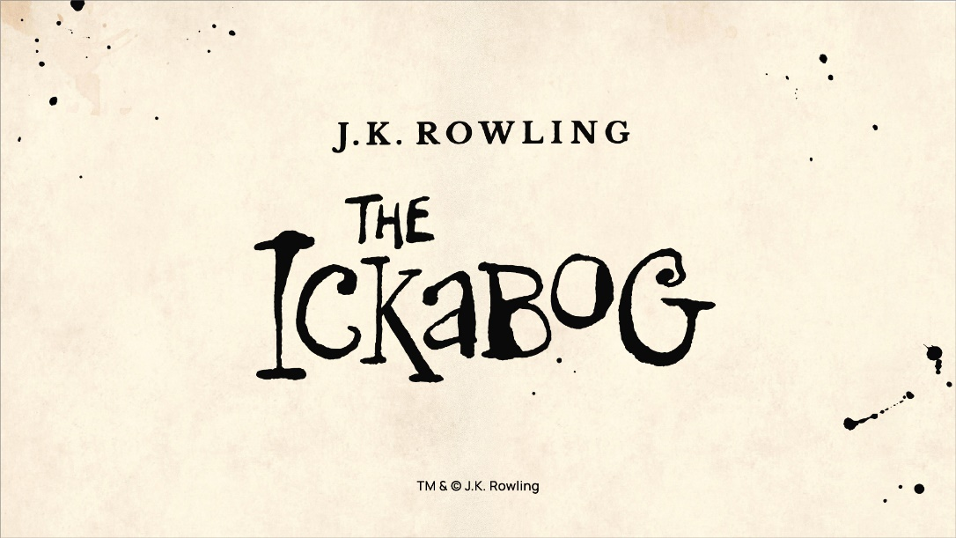
https://www.jkrowling.com/j-k-rowling-introduces-the-ickabog/
Use the link above to read about JK Rowling’s new book. In the above link, she explains when she started writing it, why it hasn’t been published for over a decade and the reasons behind starting to publish it now.
She has already published 24 chapters of the book on The Ickabog website:
The Ickabog website (you can use this link to go to that website.) You need to read each chapter (maybe read one or two chapters a day until you are caught up).
Really exciting news: JK Rowling has decided that she wants her book to be illustrated by children during lockdown. We want you to spend time over the next seven weeks, reading the story and completing some illustrations which we would love for you to enter into the illustration competition. You cannot post your competition entries until July 17th but you can work on them over the next half term. Ideas of what the illustrations may be like appear after every chapter, but in true JK Rowling style, she doesn’t want your creativity be stifled by these ideas and wants your imaginations to run wild.
We do not expect you to enter illustrations for every chapter (unless you want to) but until the end of the summer term, an afternoon a week will be given to reading the latest part of Ickabog and then completing one or more illustrations. We would love to see some of your ideas and pictures on Seesaw too.
Spend time looking at the links above and make sure you find out more about the book and competition for yourselves. The competition launched on the 26th May and there is a page on the Ickabog website:
https://www.theickabog.com/info/the-ickabog-illustration-competition-is-launched/
that gives ideas of what you could illustrate for each chapter.
We think is a unique opportunity for all of those creative and arty people. We hope you enjoy this work and look forward to seeing what you produce. Have fun Year 4.

