The Getaway
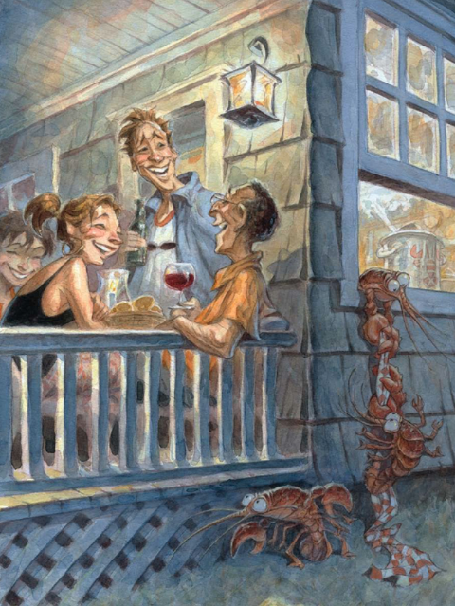

Possible ideas
- What do you think is happening here?
- Why are the lobsters escaping?
- Do the people know?
- What do you think will happen next? Will they be caught or will the go free?
- What will the lobsters do when they get away? Write about the adventures of the escaped lobsters.

