LO:To learn to write Instructions
Here is a copy of the text we have been learning and an example text map:

How To Make Turkish Delight
The sticky, soft, chewy sweet is usually incredibly floral with the flavours of rose water or orange blossom... but this version takes a green twist with Pandan extract and elderflower. Whether you know of it from Narnia or street markets and stalls across Europe and North Africa... when dusted in icing sugar and cornflour everybody want a square!
Ingredients
- 850 ml cold water
- 800 g caster sugar
- 1/4 lemon (juiced)
- 160 g cornflour
- 1 tsp cream of tartar
- 2 tbsp elderflower cordial
- 1 drop pandan extract
- 1 handful pistachio nuts
- 120 g icing sugar
- 30 g cornflour

Method
- First, dissolve the caster sugar into 350ml of the water and the juice from the quarter of a lemon in a deep saucepan over the stove. Carefully heat until the mixture reaches 118°C then take off of the heat.
- Next, dissolve the cornflour and cream of tartar in the leftover 500ml of cold water in a separate saucepan then heat to a boil as you whisk. As the mixture thickens, keep stirring slowly.
- Then, pour the sugar syrup into the cornflour paste slowly but surely, mixing well as you do it. It might go lumpy, but keep whisking. Heat very gently (as low as it’ll go) for an hour by which time you’ll have a thick, slightly golden syrup.
- After that, stir in the cordial and pandan, then mix in the pistachio nuts. Transfer to a lined and deep roasting tin (20cm x 20cm) and allow to cool and set for several hours.
- Finally, toss the icing sugar and cornflour together in a bowl. Cut the set Turkish delight into pieces and dust in a combination of the icing sugar and cornflour then serve or store in an airtight container.

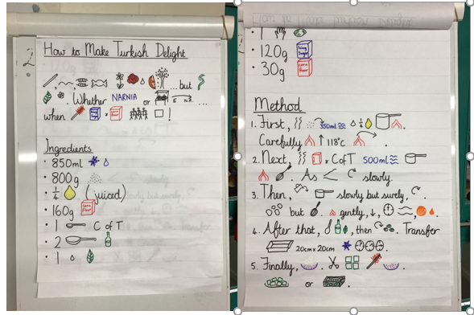

Monday – Write up your revolting recipe instructions neatly for display.
Using your neatest handwriting, write up your revolting recipe instructions so we can send a copy to Hogglestock at Cair Paravel and also so we can display some on the wall at school. Ensure that you include all the corrections you have made so that it is as perfect as possible! Once you have completed and checked your writing, you can decorate the border with pictures of your ingredients.

Tuesday – New stimulus and planning
To see how much we have learnt about instructional writing over the last few weeks, we are going to try to include all the elements from our tool kit in some new instructions.
Watch the video about how to brush your teeth. (Up to 1.50 only)
Also, have a look at the two posters below showing how to brush your teeth.
Make a plan for writing your instructions using the boxing-up grid below. Remember when you plan, you don’t need to use full sentences. This is just to help you organise your writing before you start. When you have made your plan, use it to practise SAYING your instructions out loud. Have you included everything you should have done from the toolkit? Look at the toolkit below to check.
Tomorrow we will start our writing.

Wednesday and Thursday – Writing instructions for ‘How to brush your teeth’
Use these two days to write your instructions using your boxed-up plan to help you organise your writing. Remember to check the toolkit to ensure you are including everything you need to.
Read through your writing as you write to check it makes sense and that you have used punctuation properly. You might find it easier to do this out loud. Also check your spellings as you go. You can use the instruction word mat below to help you.
Once you have completely finished your writing, read it through again to check it. Look at the toolkit again. Can you add, edit or improve anything?

