Friday 26th March
LO: To use commas in a list
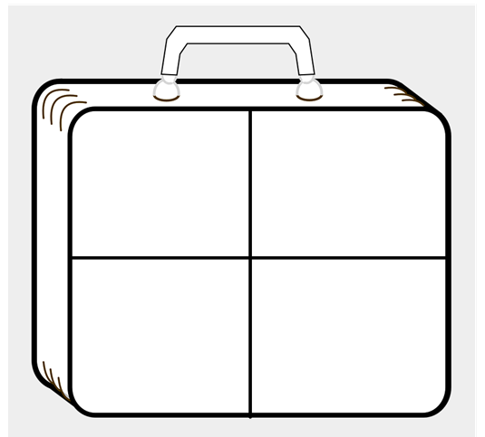
Friday 26th March
LO: To use commas in a list

