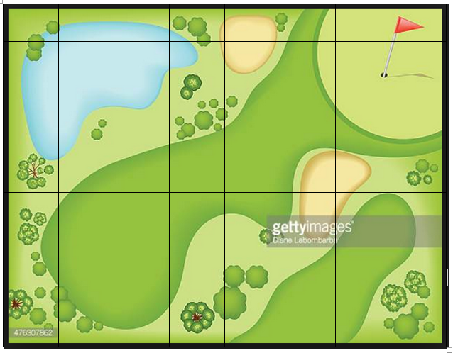

If each square represents **3** m², what is the approximate area of:

* The lake
* The bunkers
* The fairway
* The rough
* Tree/forest area

If each square represents **2** m², what is the approximate area of:

* The lake
* The bunkers
* The fairway
* The rough
* Tree/forest area

If each square represents **1** m², what is the approximate area of:

* The lake
* The bunkers
* The fairway
* The rough
* Tree/forest area