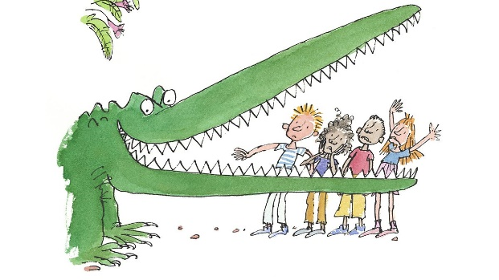
Quentin Blake
Roald Dahl is a very famous writer, he has written many stories including “Charlie and the Chocolate Factory”, “The Twits”, “Matilda” and even “The Fantastic Mr Fox” which we had started reading in class.
Many of Roald Dahl’s books are illustrated by somebody called Quentin Blake. Have a read through the information in the PowerPoint about Quentin Blake, then using the internet or any Roald Dahl books you may have in your house, look at the different illustrations drawn by Blake.
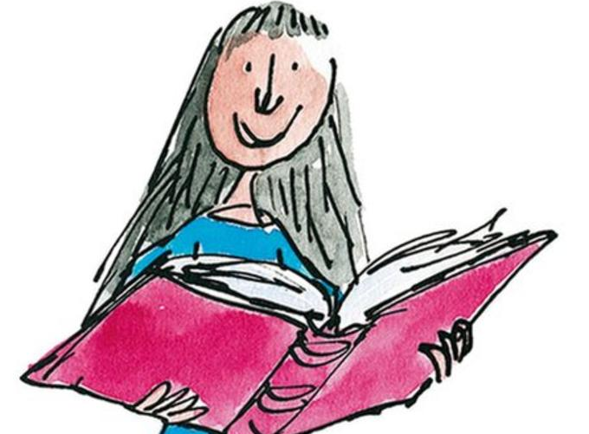
Quentin Blake describes his style of art as a ‘freewheeling sort of drawing that looks as though it is done on the spur of the moment.’ However, he says that every drawing requires planning and preparation. He usually starts with a rough drawing, where he decides how his character will stand, the type of expression they have and how they fit on the page.
Your activity- can you draw a character (it could be from a story you have made up) or a person (it could be yourself or someone in your family) in the style of Quentin Blake? Take some time to look at his style of drawing first and then have a go! I can’t wait to see what you produce.
..\Quentin Blake\Quentin Blake PP.ppt

