Wellbeing Craft
Use these instructions to create your own wellbeing jar. Having things to look forward to can make you feel happier and improve your wellbeing. Each time you think of something you would like to do in the future, write it on a piece of paper and place it inside of your decorated jar.
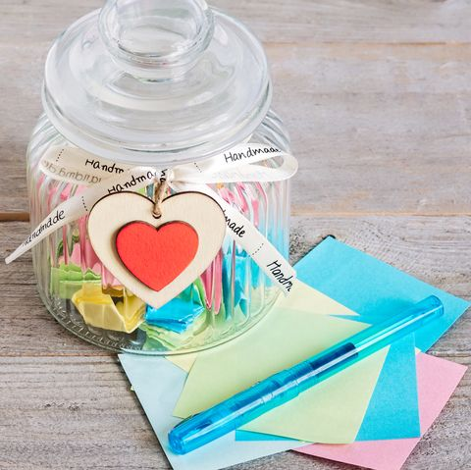
You will need:
- Jar
- Scissors
- Paper to record ideas
- Pens
- Things to decorate your jar with

Instructions:
- Begin by decorating your jar any way you like.
- Write a label for your jar, this could be “Things to look forward to”.
- Start writing some of the things that you are looking forward to. This might be seeing a family member that you haven’t seen for a while, going to the cinema or going on the swings at the park.

