The Wandering Wise Men

The Wandering Wise Men are here to follow a star and take a journey with you.

What you need are three Wise Men. Maybe if you have a nativity set you can use the three wise men from that, or what about Lego or Playmobil figures, or if you are feeling creative you could make some…
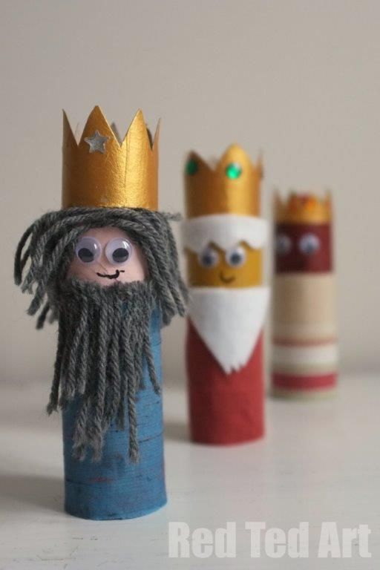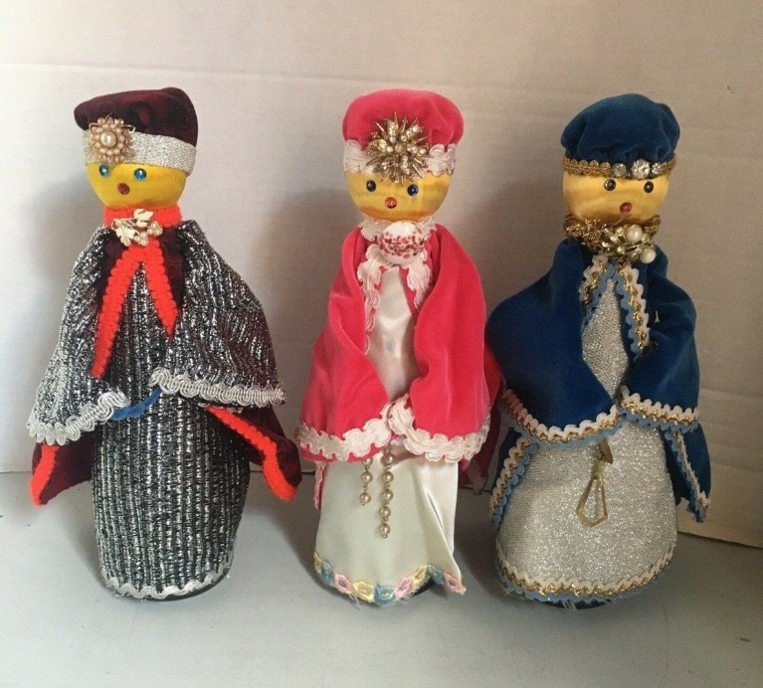
It doesn’t really matter what your Wise Men look like.

What matters is the Wise Men are on the move on their journey.

A long time ago, there was a lady called Mary. One day, while Mary was doing the washing up, she saw a bright light. She had to cover her eyes because it was so bright. The bright light was an angel. Angels are very beautiful creatures who live in Heaven and work for God. The angel gave Mary a message from God – he said she was going to have a baby.
Soon Mary’s tummy started to get bigger as the baby in her tummy started to grow. Just a few weeks before her baby was ready to be born, the king told all the people in the country that they had to travel to the place where their family was from. This meant Mary and Joseph had to go on a journey. Mary and Joseph had to travel a long way to a town called Bethlehem. Mary had to walk very slowly because she had a baby in her tummy. It was very tiring. When Mary and Joseph got to Bethlehem, all the hotels were full, so they had to sleep in a barn, where the animals sleep. That night, Mary’s baby was born. She called him ‘Jesus’. Mary didn’t have a cot to put baby Jesus in so she laid him in the animal’s food bowl called a manger! Jesus was a special baby – he was God’s baby – and God wanted everyone to know that Jesus had been born. Most of the people in Bethlehem were asleep but there were some shepherds in the fields, looking after their sheep. God sent some angels to sing to the shepherds and tell them all about baby Jesus. The shepherds were so excited that they ran to the barn to see Jesus. God also put a giant star in the sky like a big birthday candle for baby Jesus. The Wise Men were looking at the sky and they saw the special star. They followed the star all the way to baby Jesus. When they saw him, they bowed down to tell Jesus that they thought he was special and gave him presents.

