23.03.21
LO: To multiply by 8.

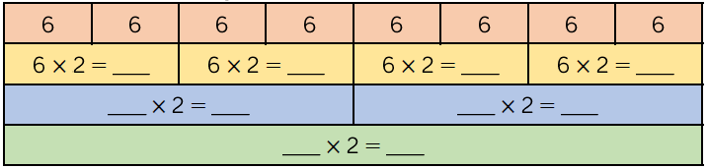

Challenge Question:
