History – Queen Elizabeth II
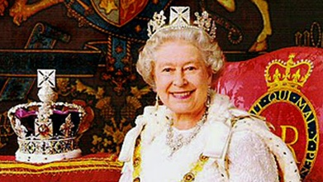
Can you write some facts that you have learnt about Queen Elizabeth II on the spider diagram?
You may wish to use the internet or books to record more facts about the Queen.

