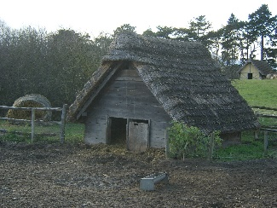
Monday 15th November
LO: To draw and label a typical Anglo-Saxon village and to understand what jobs the people did.

