WC 1/12/20
Content objective:

Me
Teacher
Skill objective:
Me
Teacher

On average, we create 1kg of rubbish per day. To help the environment, we need to think how we can reduce, reuse or recycle things we use.

REDUCE REUSE RECYCLE

REDUCE REUSE RECYCLE

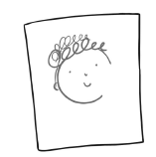 | REDUCE REUSE RECYCLE

