Tuesday 6th October
LO: To identify key physical and human characteristics

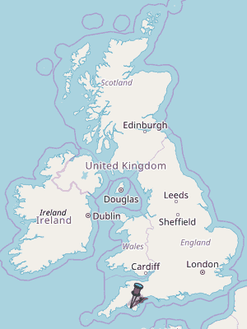
Plymouth is located in the
________________ of England.

North South East West
The area where the land meets the sea is known as the ____________.
Plymouth is a port city. What does this mean?

Plymouth has the largest Naval base in Western Europe. Have you got a question for Mrs Henderson about working in the Navy?
