Summer 1 Week 4 11-15 May 2020 Timetable Ideas
 | 9.00 – 9.30 | 9.30 – 10.00 | 10.30-11.00 | 11.00 – 11.30 | 11.30-12.00 | 12.00 – 1.00 | 1.00 – 1.30 | 1.30 – 3.00
Monday - Friday | Exercise  Joe Wicks workout  Go Noodle  Cosmic Yoga | Phonics  Every day:  - RWInc Set 2 Lesson at 10 am  https://www.youtube.com/channel/UCo7fbLgY2oA_cFCIg9GdxtQ  - Read RWInc. text  Oxford Owl.  - Write a sentence or two at some point during the day.  Other tasks:  - Revise Set 1 sounds.  - Sing the Alphabet song to learn the names of the letters.  - Read, write and match: - upper and lowercase letters  - Read and write ‘green’ words.  - Read and write ‘red’ words. | Break & Snack time | Independent activities  Drawing, writing, reading, colouring, Lego etc…  or  Gateshead’s School Sports Partnership Dance Project – see attached document. | Maths  White Rose  https://whiterosemaths.com/homelearning/early-years/  Summer Term Week 4.  The Very Busy Spider story online:  https://www.youtube.com/watch?v=YhkZi28sE_E | Lunch | Music activities  Explore:  Out of the Ark:  https://www.outoftheark.co.uk/ootam-at-home/  Storytime  Storytime with Nick  https://www.youtube.com/channel/UCo7fbLgY2oA_cFCIg9GdxtQ | Spider Linked activities  Go for a walk and look for spider webs.  Draw a picture of the places you found webs.  Can you write a sentence about where you found webs?  Spider hand prints – see below.  Find out about Robert the Bruce and the Spider.  https://www.youtube.com/watch?v=j2HMBGELeFM  Can you think of times when you have to try and try again to succeed?  Make biscuits and decorate them as spiders. You could use coloured icing or sweets!  Find out some facts about spiders.  Do they all look the same?  Are all spiders dangerous?  Where in the world can you find spiders?

Spider hand prints
Simply paint or dip your child’s palm and four fingers with black paint. No need to paint the thumb since spiders only have 8 legs;) Print onto the paper and repeat with the other hand, making sure to over-lap their palms. Add a couple googly eyes and your little spider is done!
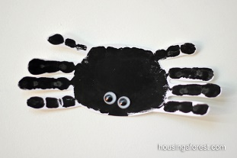
Biscuit Recipie
https://www.bbcgoodfood.com/recipes/basic-biscuit-dough

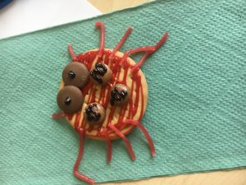

Chocolate Spider Cookies
https://www.bbcgoodfood.com/recipes/chocolate-spider-cookies
