WC Monday 8th March
LO: To use compass directions to describe the location of features on a map

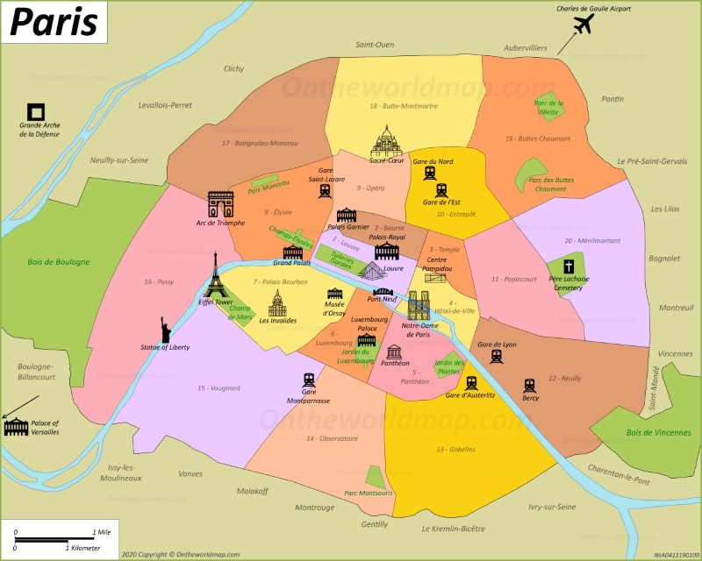

The Eifel Tower is ____________________________ of the Arc de Triomphe.
The Louvre is ________________________________ of the Eifel Tower.
Notre Dame Cathedral is _______________________ of Sacre Coeur.
The Arc de Triomphe is ________________________ of the Louvre.

