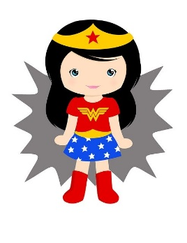
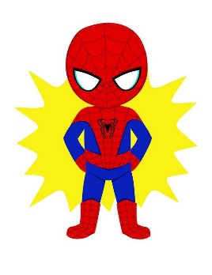
Nursery Home Learning ideas
Week Beginning Monday 20th April
Superhero Week

Perhaps start the week with a Superhero themed story or two?
If you haven’t got any superhero books in your collection at home there are lots online that you can watch. Here are some of our suggestions:
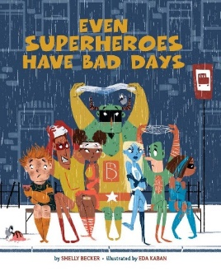
- Even Superheroes have bad days:
https://vimeo.com/216918288
- Superworm:
https://www.youtube.com/watch?v=LRdbB_tRPsg
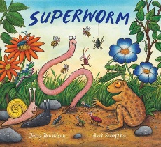

- Supertato:
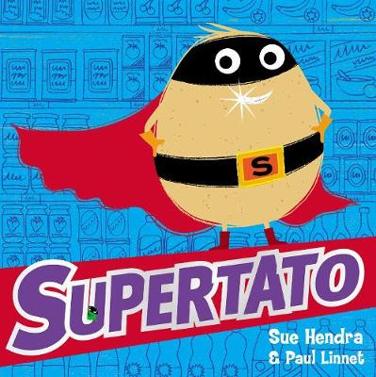
https://www.youtube.com/watch?v=QlaMeNmTG6c

Each day can you fit in some Superhero exercise?
Maybe do the Joe Wicks workout live on YouTube at 9am daily
Or try one of these:
- 5-minute Superhero kids workout:
https://www.youtube.com/watch?v=cvMbkw2572k
- Superhero workout for kids:
https://www.youtube.com/watch?v=ZKaawxjN3yM

- Or set your children superhero challenges such as:
‘Do 5 big jumps’
‘Slide along the floor’
‘run on the spot until I say stop’
‘spin around 3 times’ etc…
- ‘Spread the Happiness’ YouTube channel has lots of dough disco videos to follow, including some Superhero themed ones.

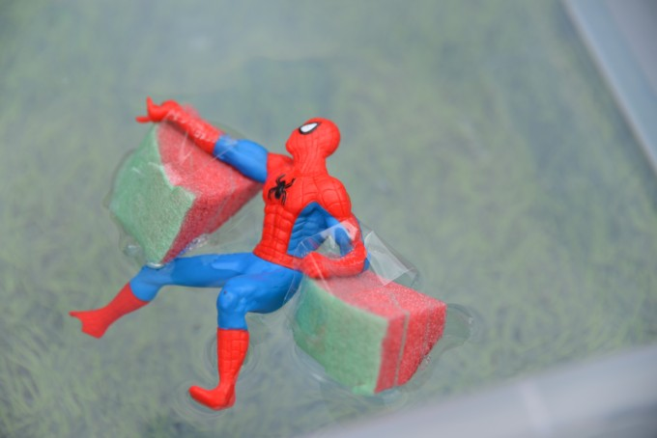
Can you make your Superhero float?
If you have any superhero toys, can you make them
a boat or just let your child experiment with
floating and sinking with a washing up bowl full of water.

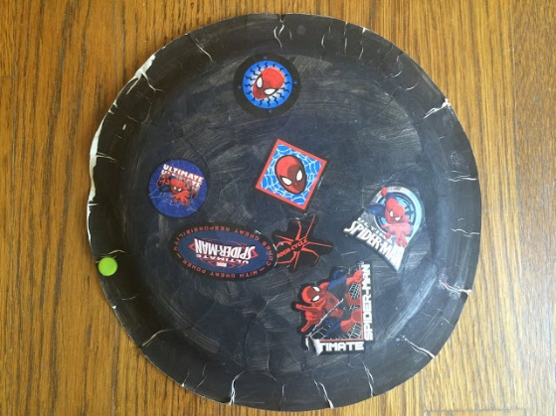
Can you make a toilet roll superhero cuff or paper plate / cereal box shield?
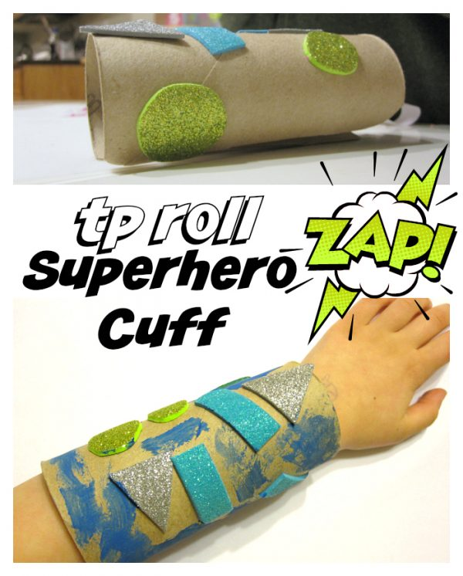

Use whatever recycling materials you have in the house to make superhero props. Perhaps these could be used with a fancy-dress costume if you have one or make a cape from some old material / clothes?
What about making a superhero vehicle or a superhero den from cushions or blankets?

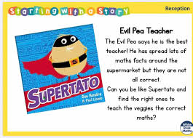
Maths
- Use the ‘White Rose’ website:

https://whiterosemaths.com/homelearning/early-years/

There is a home learning section for Early Years. If you find the section for this week, all of the activities are based around the book ‘Supertato’.

Each day there are different activity ideas. Each day begins with a 5-minute video to watch. The video starts with the ‘days of the week’ song which the children should know!

Dancing
The children will probably all recognise the two dances below as they are firm favourites:
- Koo Koo Kangaroo – Superheroes unite – dance-along https://www.youtube.com/watch?v=ok7V1pWtRzs

- Superman kids party dance
https://www.youtube.com/watch?v=83aUaYQF4NM

Cooking / Baking
- Make a superhero (fruit) salad
- Make some superhero sarnies
- Decorate some plain biscuits with icing and sweets to look like superhero faces
- Squeeze some oranges to make orange juice ice cubes / mini ice lollies for superhero strength

Mark making / drawing
- Design a superhero – use the attached template if you can print it out or draw it on paper. If you have any big paper such as a roll of old wallpaper, you could draw around a real person and draw in all their superhero body parts. You could also try this with chalk outside if you have any.

- Design a mask – use the attached template or draw your own

Cola super fountain science experiment
Maybe have a go at the attached science experiment – you just need cola and mints.

Other ideas:
- Letters and Sounds website phase 1 Listening games:
http://www.letters-and-sounds.com/phase-1.html

- Use the 30-day free trial at Reading Eggs to practise listening games and phonics / letters games:
https://readingeggs.co.uk/

- Draw a picture to post to a family member / friend

- Make some ‘gloop’ – just mix together 2 cups of cornflour with 1 cup of water

Remember these are all just ideas, please do not feel like you have to do all of them.
Keep reading lots of books, singing songs and nursery rhymes and encouraging as much mark making with pens, pencils, paint, chalks and crayons as possible.
Keep in mind that with young children, its all about the process, not the product…it doesn’t really matter what the finished result looks like!

