Design for “The Butterfly Effect”
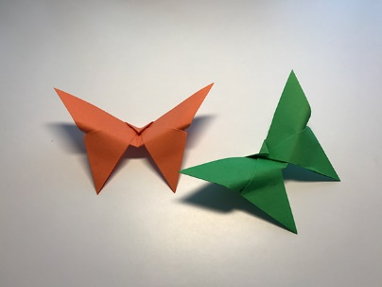
Name:
Age:
Class:

Please write a brief description of your design below:

