Challenge:
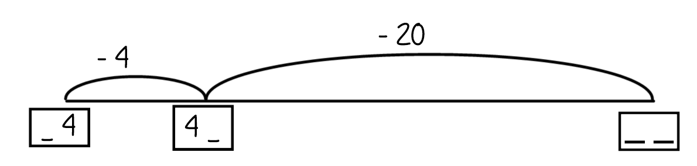
Challenge:

Challenge:
Challenge:

