Wednesday 10th March.
LO: I can learn about the River Nile and its importance.

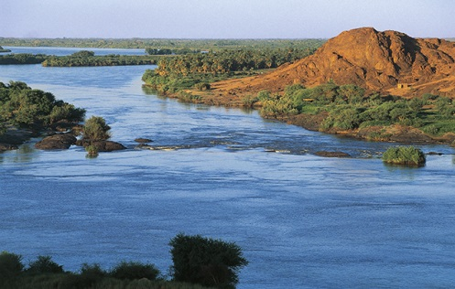

Monday 11th March
LO: Learn about the River Nile and its importance.

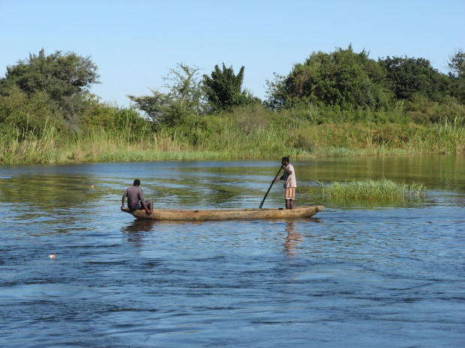

Monday 11th March
LO: Learn about the River Nile and its importance.

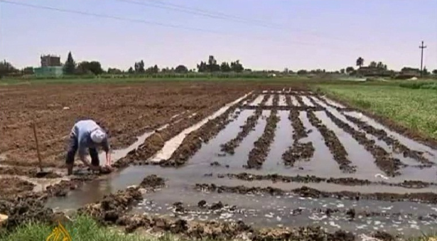

Monday 11th March
LO: Learn about the River Nile and its importance.

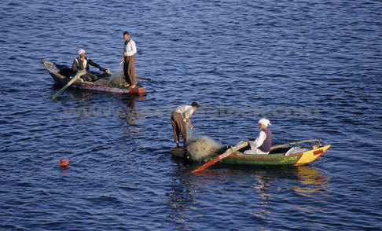

Monday 11th March
LO: Learn about the River Nile and its importance.

