Nursery Home Learning ideas
Nursery Home Learning
Nursery 8th March 2021

Literacy
- Read some Spring themed books if you have any at home…or watch some:

https://www.youtube.com/watch?v=ls6wTeT2cKA

https://www.youtube.com/watch?v=icw9oEWDm4E

- Squiggle Whilst you Wiggle
Play the song: Dizzy by Reeves and Mortimer and dance making the snail shell movement with your arms. Use some cloths or tea towels as flappers.

Then move to your paper and draw this shape. This Squiggle is made by circling inwards and spiralling outwards. This will help with forming the letters – k p.

Mothers’ Day
- Listen to this Mothers’ day song- talk about why your mammy is important and what she does for you.
https://www.youtube.com/watch?v=HL5GUuK49Ag

- Make a Mothers’ Day card. You could use the tulip design below for the front.

Art Projects

- Cut and stick sunshine
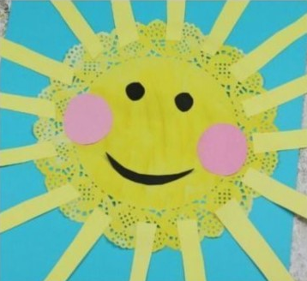

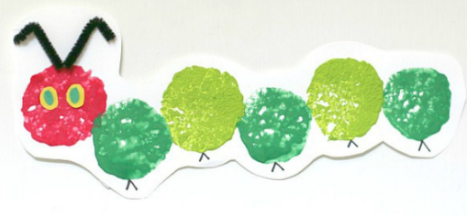
- Printing using a cork or a sponge

- Painting tulips with forks
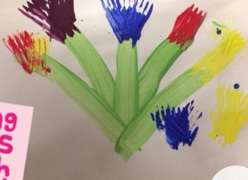
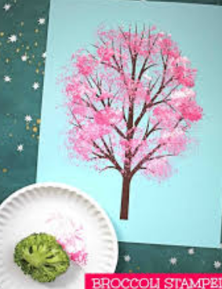
- Broccoli print blossom trees

Cooking/baking
We are making pitta pizzas in school this week. Have a go at home!
- Spread tomato puree on your pitta bread.
- Top with grated chees
- Select your toppings and place on top of the cheese. We have gone for ham, mushrooms and red pepper.
- Put it in the oven 180 degrees for 10 minutes or until the cheese melts. Enjoy!

Phonics
- Have a go at the rhyme game ‘hickory dickory dock:
https://www.phonicsplay.co.uk/resources/phase/1/hickory-dickory-dock

Exercise Time!
- Dough Disco
Grab some dough and copy the moves on this video!

https://www.loom.com/share/65c239f67f6c4e55a03872da2c846b25

