Nursery Home Learning

Week Beginning 29th March

**Literacy**

* Read or listen to some Easter themed stories

<https://www.youtube.com/watch?v=HirSM6v7hQI> 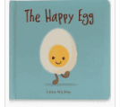

<https://www.youtube.com/watch?v=Q35GN23ZFzM> 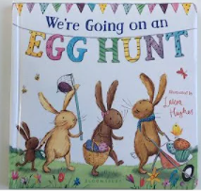

<https://www.youtube.com/watch?v=8LKoji2i7Cw> 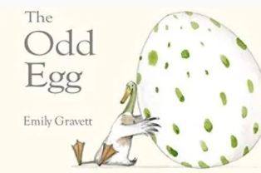

**Maths**

* Make some repeating patterns on Easter eggs. Start with two colours then move onto three. Give different shapes a go too!





**Art Projects**

* Draw around your hand and make an Easter Bunny.

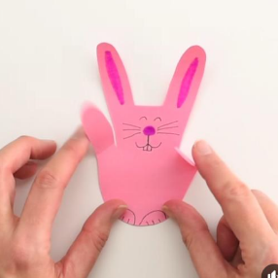

* Decorate some boiled eggs and post a photo on Tapestry for our Family Egg competition.

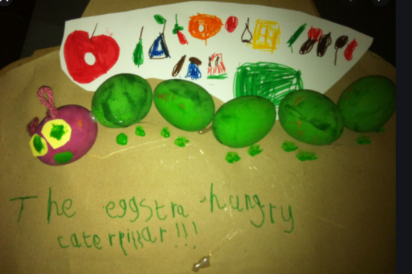

**Exercise time**

* Go Noodle dancing

[**https://www.youtube.com/watch?v=KhfkYzUwYFk**](https://www.youtube.com/watch?v=KhfkYzUwYFk)

[**https://www.youtube.com/watch?v=1b6axyuaKcY**](https://www.youtube.com/watch?v=1b6axyuaKcY)

[**https://www.youtube.com/watch?v=388Q44ReOWE&t=99s**](https://www.youtube.com/watch?v=388Q44ReOWE&t=99s)

**Signing and signing**

* Learn Makaton for chick chick chicken.

Watch Mr Tumble practise the Makaton signs whilst singing.

<https://www.youtube.com/watch?v=BUBq5RsIYDg>