Summer 2 Week 1: Timetable Ideas
Under the Sea Week
 | 9.00 – 9.30 | 9.30 – 10.30 | 10.30-11.00 | 11.00 – 12.00 | 12.00 – 1.00 | 1.00 – 2.00 | 2.00 – 3.00
Monday - Friday | Exercise  See the options below under ‘exercise’ | Phonics  DAILY:  RWInc Set 2 Lesson at 10 am  https://www.youtube.com/channel/UCo7fbLgY2oA_cFCIg9GdxtQ  Practise red and green words from pack  Read RWInc. Text on Oxford Owl website (see individual Tapestry posts)  Phonics Play – try Phase 2 then Phase 3  https://www.phonicsplay.co.uk/PictureMatch.html | Break & Snack time | Maths  See further guidance under ‘maths’ below | Lunch | Under the Sea  See further guidance under ‘Under the Sea’ below | Daily walk / play in the garden / free play

Exercise
- Andy’s Wild Workout
https://www.bbc.co.uk/iplayer/episode/p06tmn51/andys-wild-workouts-series-1-1-under-the-sea
- Cosmic Yoga – Squish the Fish
https://www.youtube.com/watch?v=LhYtcadR9nw
- Deep Sea Core Strength
https://www.youtube.com/watch?v=pi6Sg4dKgZ0
Maths
This week we will be using the Numberblocks to help us with our maths work
- Monday – looking at the number 16 https://www.bbc.co.uk/iplayer/episode/m0005yfs/numberblocks-series-4-sixteen try putting your number cards in order up to 16. Can you find 16 objects to match the number card 16? Notice that 16 is made up of 10 and 6.
- Tuesday – use Top Marks to play the underwater counting game https://www.topmarks.co.uk/learning-to-count/underwater-counting
- Wednesday – looking at the number 17 https://www.bbc.co.uk/iplayer/episode/m00063vv/numberblocks-series-4-seventeen try putting your number cards in order up to 17. Can you find 17 objects to match the number card 17? Notice that 17 is made up of 10 and 7.
- Thursday – watch the Numberblocks episode about doubling https://www.bbc.co.uk/iplayer/episode/b08q4jkq/numberblocks-series-2-double-trouble Try some practical doubling activities (find the doubles on dominoes, find a group of objects and place them next to a mirror or give two teddy bears the same amount of objects each and find the doubles)
- Friday – complete the butterfly doubling sheet.

Under the Sea
- Monday:
Listen to the story of Little Crab.
https://www.bbc.co.uk/iplayer/episode/m000hs3d/cbeebies-bedtime-stories-752-tom-hardy-dont-worry-little-crab Have you got any other Under the Sea books in your collection at home that you can have a look at?
Some other stories you might like to look at on You Tube are
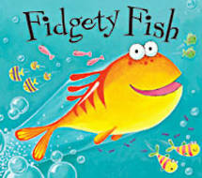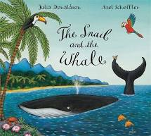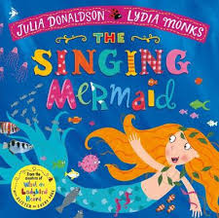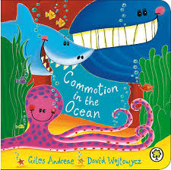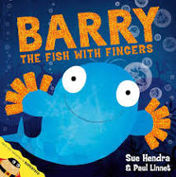
- Tuesday:
Watch the Blue Planet Clip https://www.youtube.com/watch?v=kAphgHhlteM Which ocean animals did you see in the clip? Research your favourite ocean animal. Can you draw a picture of your animal? Can you write some interesting facts or label your animal?
- Wednesday:
Use materials from your house to make your own sea creature (see below for some ideas)
- Thursday:
Make an under the sea snack to eat (see below for some ideas)
- Friday:
- Listen to the story of The Rainbow Fish https://www.youtube.com/watch?v=BzZuS3ze-Ho Talk about how the characters feel in the story. Discuss what makes a good friend. Talk about how the Rainbow Fish shared his scales. Discuss a time you shared something.

Art ideas
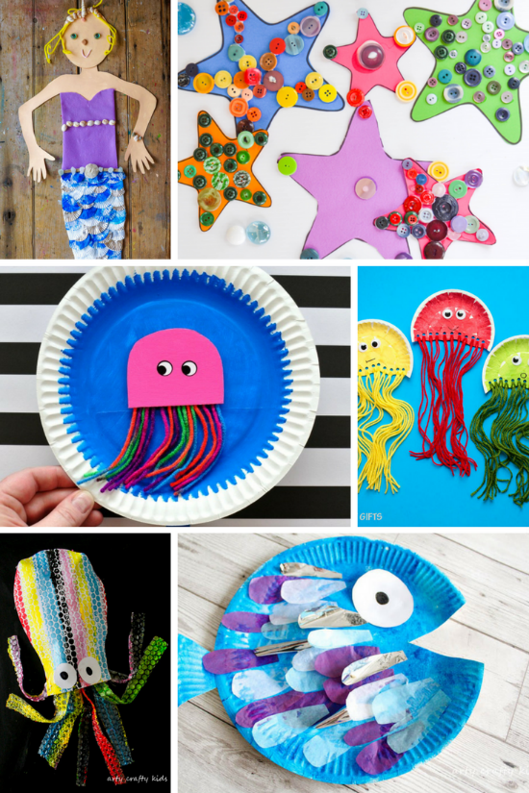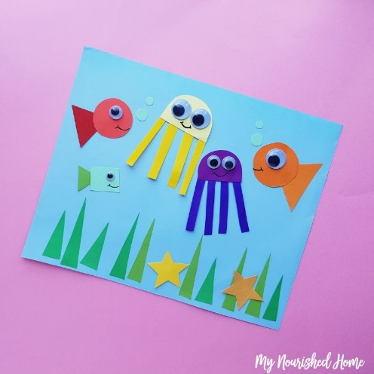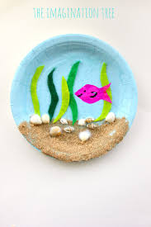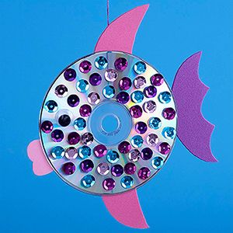
Snack ideas
