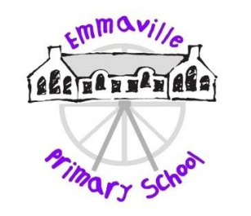

Protected Characteristics at Emmaville

The Equality Act became law in 2010. It covers everyone in Britain and protects people from discrimination, harassment and victimisation.

The Equality Act protects people against discrimination because of the protected characteristics that we all have.

Under the Equality Act, there are nine protected characteristics:

1. Age
2. Disability
3. Gender reassignment
4. Race
5. Religion or belief
6. Marriage or civil partnership
7. Sex
8. Sexual orientation
9. Pregnancy and maternity

No form of discrimination is tolerated at Emmaville Primary School and our pupils show respect for those who share the protected characteristics.

Our Jigsaw PSHE curriculum helps children understand and promote these characteristics more fully and in an age appropriate way. The Puzzle ‘Celebrating Difference’ focuses on similarities and differences and teaches about diversity, such as disability, racism, friendships and conflict. Children learn to accept everyone’s right to ‘difference’. The Relationships Puzzle also has a wide focus, looking at diverse topics such as families and friendships exploring roles and responsibilities in families, and looking at stereotypes. All Jigsaw lessons are delivered in an age/stage appropriate way so that they meet children’s needs and can help them understand the wider world.

We also embed a culture of developing pupils’ understanding of the protected characteristics through the literature we use. We have a wide range of books relevant to all age groups which will ensure that gender and gender identity, religion, race, sexual orientation, disability and age is explored. Through book sharing and discussion children are encouraged to show respect and develop their understanding of diversity in a subtle way.