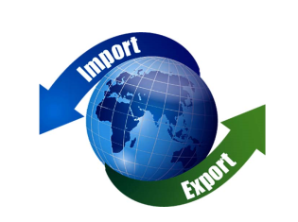
04.01.22
LO: To understand what trade is.
LO: To discover how and why trade has become ‘global’.

Name of item/ object | Where it was made
1.
2.
3.
4.
5.
6.
7.
8.
9.
10.

