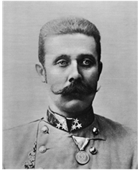
The assassination of Archduke Franz Ferdinand
- Archduke Franz Ferdinand - in charge of Austria-Hungary
- Trying to take over another country called Serbia.
- June 28th 1914, the Archduke and his wife Sophie decided to visit Serbia.
- Group of Serbian men (the ‘Black Hand’) attacked them.
- One threw grenade - exploded under wrong car - injured people inside
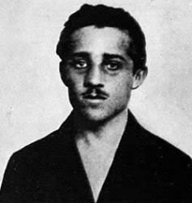
- After lunch, Franz & Sophie went to visit injured people in hospital
- Driver took a wrong turn - car stopped to reverse
- Gavrilo Princip (Black Hand member) stepped forward and shot both the Archduke and his wife.
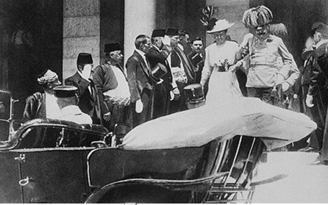

Empires
- Many countries in Europe had already taken over and 'owned' other countries
- Enabled them to easily take valuable resources & sell products back to those countries
- Some countries had much bigger empires than others
- Caused much tension between countries – always competition to grow empires
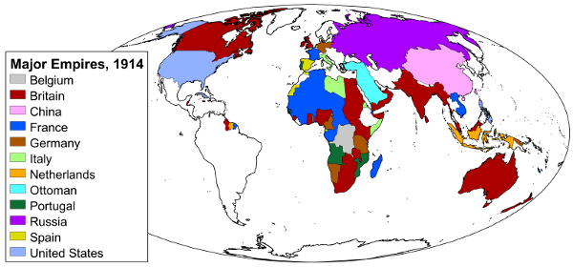

Arms Race
- Before 1914, countries in Europe began spending more money on armies, navies & weapons
- Wanted to defend themselves in case they were invaded by other countries
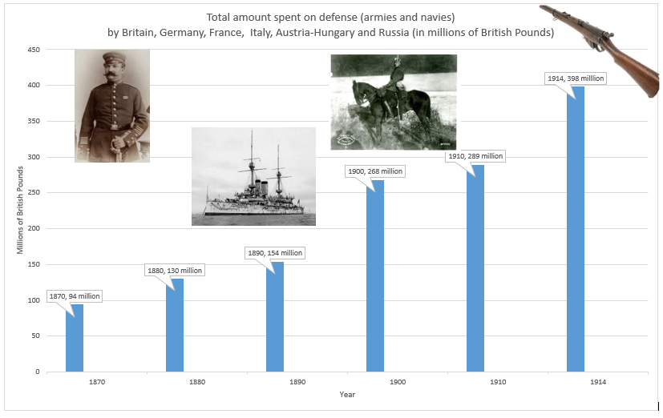
- In 1906, Britain built HMS Dreadnought – bigger, better & faster than any other ship

Alliances
- Everyone nervous about other countries invading their own
- Some countries decided to form an alliance - promised to help each other
- In 1882, Germany, Austria-Hungary and Italy formed the Triple Alliance
- Promised to help each other if any other country attacked one of them.
- In 1907, France, Russia and Britain formed the Triple Entente (French for 'friendship or agreement').
- They agreed to help each other if anyone from Triple Alliance attacked.
