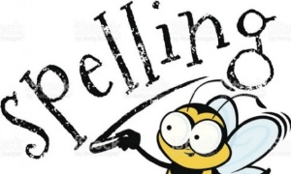
Choose the right word – words beginning wr-

Look at the words in the boxes below. Choose which word would complete the sentences.
writing | write | wrote | wrestling | wrestled
wrinkles | wrinkle | wrinkled | wriggled | wriggling

- I like ____________ stories about magic.

- Josh ___________ a thank-you letter to his gran.

- My sister watches _________________ on TV.

- The woman bravely ___________ the jewels from the thief.

- My fingers were ___________ after my bath.

- There is a _____________ in my bedroom wallpaper.

- He _______________ through the tiny tunnel.

- I held on tightly to the _____________ kitten.

