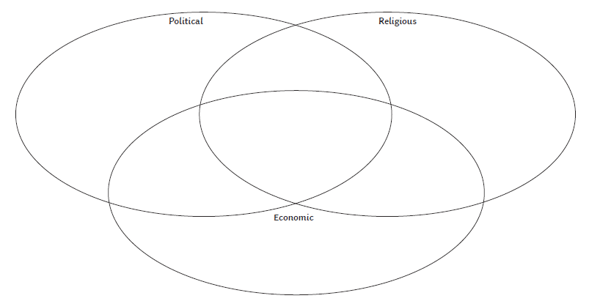

Relationships

Religion

Financial

Relationships