Sights | Sounds
Smells | 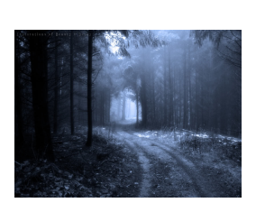  Feelings/Emotions
LO: To generate descriptive phrases

