18.01.2022
L.O I can subtract numbers up to 20.

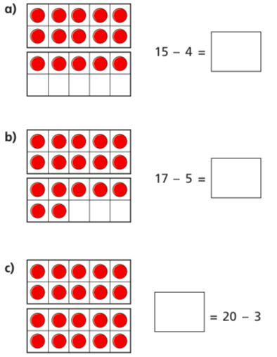
- Cross out counters to work out the subtractions.

