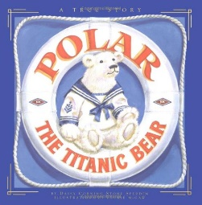
WC Monday 22nd March
LO: To describe historical events

Titanic | New York | Master
iceberg | lifeboat | Carpathia

Dear Diary,

WC Monday 22nd March
LO: To describe historical events

Titanic | New York | Master
iceberg | lifeboat | Carpathia

Dear Diary,

