PSHE – Celebrating Difference - Problem solving a bullying situation.
LO: To know that witnesses can make the situation better or worse by what they do
LO: To problem-solve a bullying situation

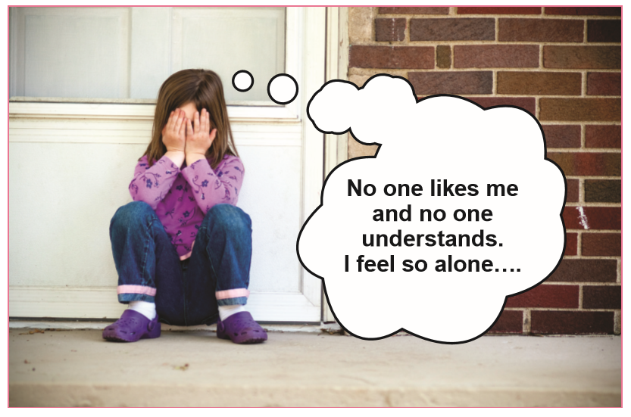
Look at the picture. What do you think has just happened to make this person think/feel this?
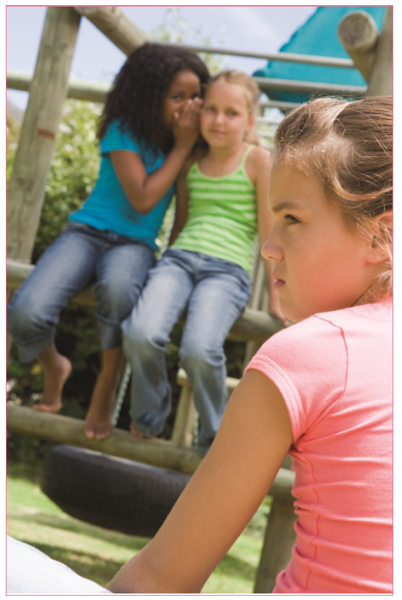
What do you think is happening in the picture? If someone saw this happen, what would they feel? What might they say or do? What would you do if you saw this happen?

Look at the ‘Solve it together’ technique on the next page. Can you apply this to the problem in the picture?
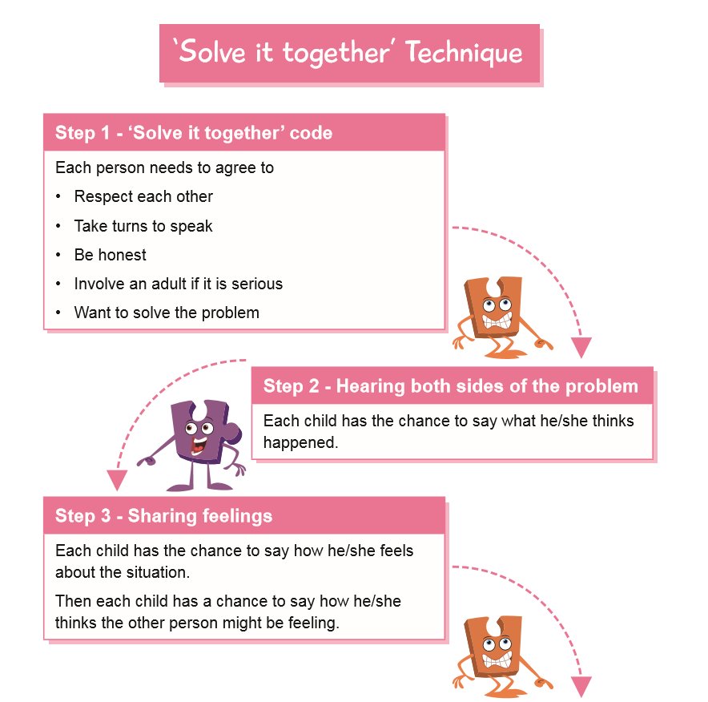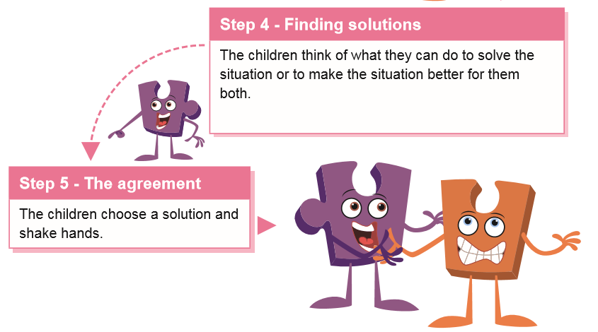
How can the situation be resolved? What do you think would happen if the children in the picture used the ‘Solve it together’ technique? Draw a picture or write about how you think this problem could be resolved.

NOTE FOR PARENTS:
Homophobic language and bullying
Children often use the word ‘gay’ as a derogatory term, sometimes without understanding what it means. Often, children think it means ‘stupid’. The most important thing is to emphasise that no words should be used to hurt people. However, it may be necessary to give an explanation what the word actually means. This needs to be done sensitively and appropriately with regard to children’s age and maturity level. It is usually enough to explain to children that being gay means being attracted to/ loving someone of the same sex in a boyfriend/girlfriend relationship. Using the word ‘gay’ in a derogatory way is seen as homophobic and, as such, is completely unacceptable.

