Summer 2 Week 4: Timetable Ideas
Space and Aliens Week
 | 9.00 – 9.30 | 9.30 – 10.30 | 10.30-11.00 | 11.00 – 12.00 | 12.00 – 1.00 | 1.00 – 2.00 | 2.00 – 3.00
Monday - Friday | Exercise  See the options below under ‘exercise’ | Phonics  Play phonics play game – try phase 2 then phase 3  https://www.phonicsplay.co.uk/resources/phase/2/picnic-on-pluto  Revise Set 1 and Set 2 sounds  Play Bingo or splat the word using the red word cards  Read Oxford Owl RWI texts  Watch one of the ‘red words’ and one of the ‘read and hold a sentence’ videos  https://www.youtube.com/channel/UCo7fbLgY2oA_cFCIg9GdxtQ | Break & Snack time | Maths  See further guidance under ‘maths’ below | Lunch | Space/Aliens  See further guidance under ‘Space/Aliens’ below | Daily walk / play in the garden / free play  Sing some alien/space themed songs  Five Little Men  Zoom, zoom, zoom  Twinkle, twinkle
Exercise
- Mike and Muttnik on the Moon Cosmic Yoga https://www.youtube.com/watch?v=v9W8iV4AJYQ
- Encourage the children to explore different ways of moving to represent different space items - e.g. crouching down and leaping up as a rocket lifting off into space; large, slow steps like an astronaut walking on the Moon; running around like a flying saucer whizzing around in space or being an alien with bouncy or wobbly steps.
- Astronauts dance https://www.youtube.com/watch?v=HSYaEBcl8xI
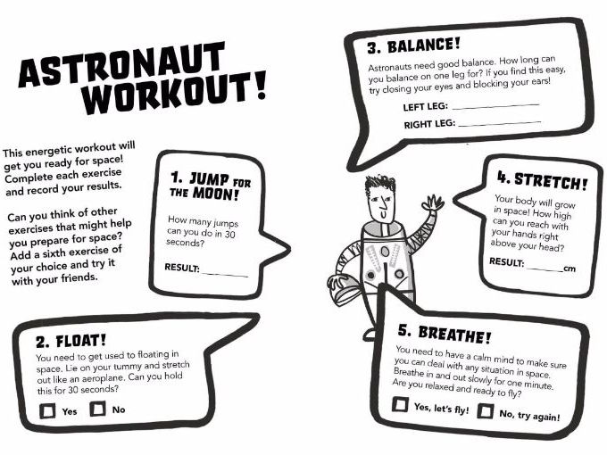

Maths
This week we will be using the Numberblocks to help us with our maths work
- Monday – looking at the number 18 https://www.bbc.co.uk/iplayer/episode/m00064tz/numberblocks-series-4-eighteen can you find 18 items from around your house (for example, 18 spoons, 18 socks or 18 buttons)? Notice that the number 18 is made up of 10 and 8. Play a game of number recognition Bingo.
- Tuesday – Complete some of the home learning challenges for number 18 (see attachment)
- Wednesday – watch the Numberblocks episode about odd and even numbers https://www.bbc.co.uk/iplayer/episode/b08r2l4d/numberblocks-series-2-odds-and-evens Provide pots of items containing quantities from one to ten (for example, paper cups with buttons inside). Ask your child to count the items in each pot and decide if there is an odd or even quantity. To make it more visual put each item from the pot side by side in pairs as you’re counting – explain that, if there are no items left over, it is an even number but if there is an item left by itself it is an odd number.
- Thursday – Talk about the digits that odd and even numbers end with. Play the coconut Top Marks game identifying odd and even numbers https://www.topmarks.co.uk/learning-to-count/coconut-odd-or-even On your daily walk look at numbers on doors – are they odd or even?
- Friday –Complete the odd and even caterpillar sheet. You may need to use your practical resources from Wednesday to help work out the odd and even numbers.

Space/Aliens

- Monday:
Listen to the story of Aliens Love Underpants https://www.youtube.com/watch?v=HWbSrmuyptw
Have you got any other Alien or Space books in your collection at home that you can have a look at?
Some other stories you might like to look at on You Tube are
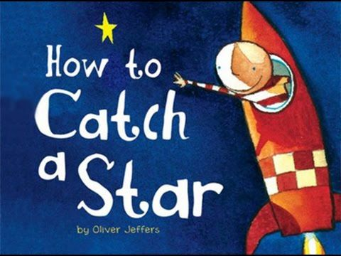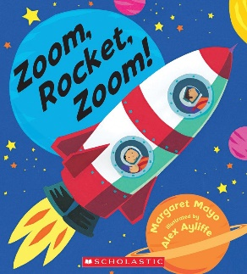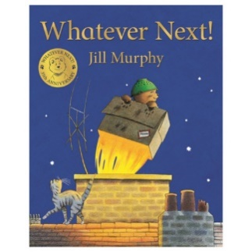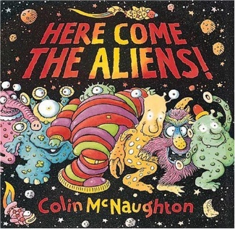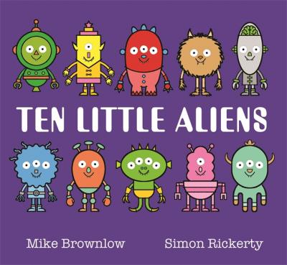
- Tuesday:
You may have watched the latest rocket launch on the news – if not watch the clip here. If you were going to Space, what would you take with you? Can you write a list on the sheet provided? Don’t worry if you can’t think of ten things just write what you can.
- Wednesday:
Use the template to design your own alien character – can you give it a name?
- Thursday:
Try the Bubbling Planet experiment. Before beginning look at the planet poster and discuss. What is the name of the largest planet? Which is the smallest planet? Which planet is closest to the Sun? Do you have a favourite planet? Then start your experiment. What colours do you need to make your favourite planet? Can you mould the baking soda and water into a ball? What happens to your planet as the vinegar is dropped on it?
- Friday:
Art: Can you make a spaceship for an alien or a rocket which can travel to space?

Art ideas
