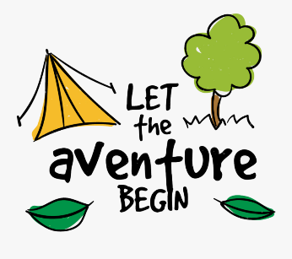
Wednesday 3rd March
Planning an adventure story
Beginning
Introduce your character(s) and story setting.
Middle
Your main character goes on a quest/ adventure or escapes danger.
End
The problem is resolved. Your main character might have learned something from their adventure.

